

**Contact**

**Send you Cv’s to** [**hr@mazco.com.sa**](mailto:hr@mazco.com.sa)

**Or**

**Post Box: 2486, Dammam 31451,**

**KINGDOM OF SAUDI ARABIA.**

**Tell: +966 3 8260080 EXT: 31**

**Fax : +966 3 8266618**

**Website::**[**www.mazco.com.sa**](http://www.mazco.com.sa)

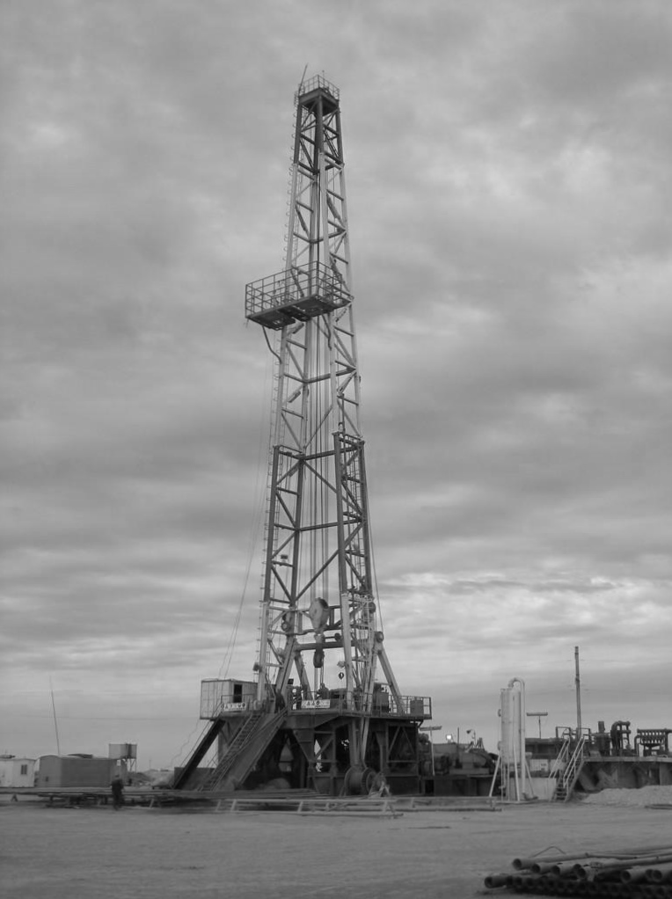

### **Job Specification:**

**SENIOR DRILLER**

* Supervise the repair of high pressure pump and associated valves, align mud system valves and transfer fluid from one pit to another.
* Inspect safety lines ropes, air hoists, monkey board, derrick fingers, stabbing boards, sheaves, crown blocks, derrick bolts, pins, welds, and other equipment related to the derrick utilizing proper safety equipment, mixing drilling fluids and chemicals.
* Monitor mud properties and perform calculations, recognize warning signs of kicks and stab casing from casing stabbing board.
* Possess full understanding of blow-out prevention equipment and assist in nipping them up and down.
* Identify and set priorities for the work, direct and coordinate crew members in performing the work, verify that appropriate tools and equipment are available and in working order at the appropriate time.
* Direct and coordinate the use and storage of hand and power tools, handling of drill string hoisting and rotating equipment.

### Qualification:

* Requires a comprehension of English to follow oral and written orders.
* Have a minimum of six years rotary rig experience as a driller.
* Must be able to work at extreme heights without abnormal fears.
* Familiar with drilling tools and equipment, drilling practices and procedures.
* Must be holding a valid supervisory IWCF or Well Cap Well Control certificate.

Senior Driller